**Section 2 - Sequence Allignment**

**Ans 1.**

|  |  |  |  |  |  |  |  |  |  |  |  |
| --- | --- | --- | --- | --- | --- | --- | --- | --- | --- | --- | --- |
|  | - | **H** | **E** | **A** | **G** | **A** | **W** | **G** | **H** | **E** | **E** |
| - | 0 | -8 | -16 | -24 | -32 | -40 | -48 | -56 | -64 | -72 | -80 |
| **P** | -8 | -2 | -9 | -17 | -25 | -33 | -41 | -49 | -57 | -65 | -73 |
| **A** | -16 | -10 | -3 | -4 | -12 | -20 | -28 | -36 | -44 | -52 | -60 |
| **W** | -24 | -18 | -11 | -6 | -7 | -15 | -5 | -13 | -21 | -29 | -37 |
| **H** | -32 | -14 | -18 | -13 | -8 | -9 | -13 | -7 | -3 | -11 | -19 |
| **E** | -40 | -22 | -8 | -16 | -16 | -9 | -12 | -15 | -7 | 3 | -5 |
| **A** | -48 | -30 | -16 | -3 | -11 | -11 | -12 | -12 | -15 | -5 | 2 |
| **E** | -56 | -38 | -24 | -11 | -6 | -12 | -14 | -15 | -12 | -9 | 1 |

Optimal Global Alignment:

|  |  |  |  |  |  |  |  |  |  |  |
| --- | --- | --- | --- | --- | --- | --- | --- | --- | --- | --- |
| H | E | A | G | A | W | G | H | E | - | E |
| - | P | A | - | - | W | - | H | E | A | E |

Linear gap penalty = -8

Alignment Score = Gap penalties + Sum of pairwise alligned symbols

= 5*(-8) – 1 + 5 + 15 + 10 + 6 + 6

= 1

**Ans 2.**

Sequence 1: GCA, Sequence 2: GA

d\g0 = -7, M/M = -3

e\ge = -2, M = 1

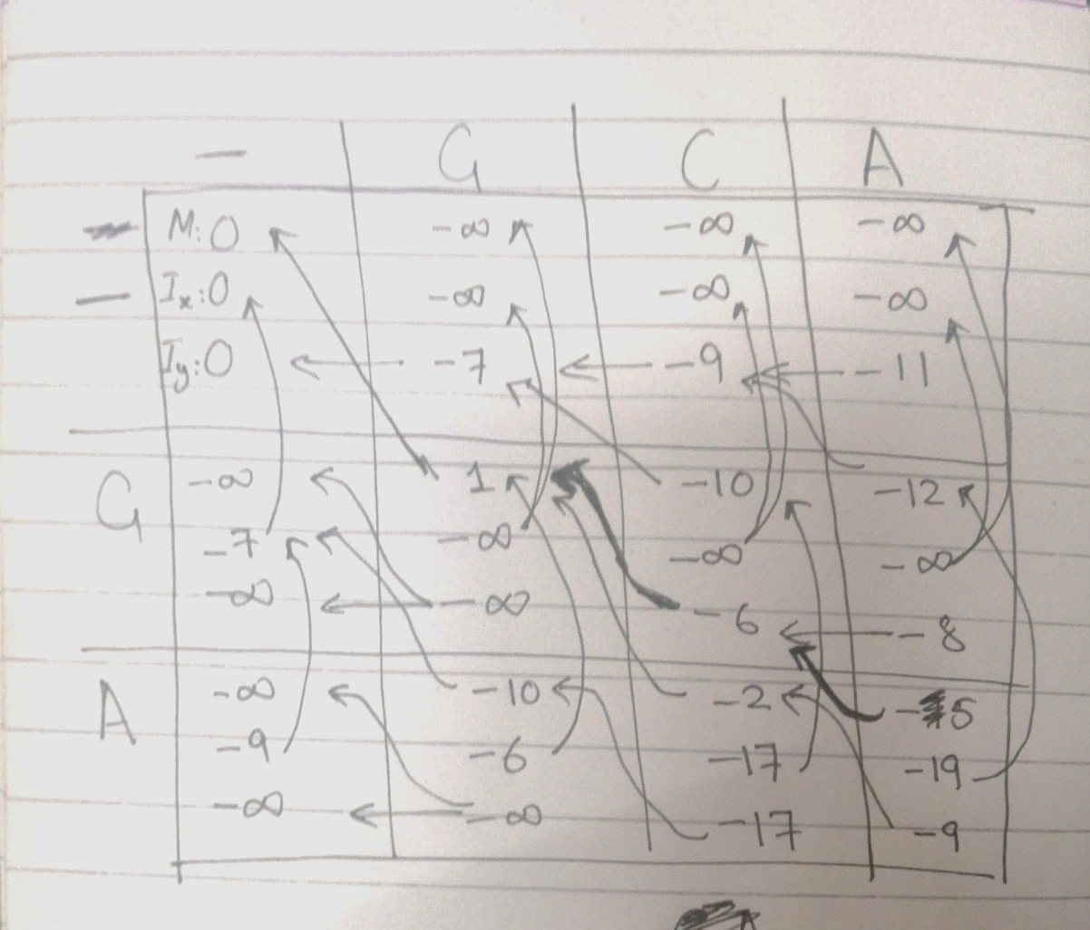

Global Affine Gap Penalty Model Allignment:  
 G-A

GCA

Alignment score: 1-3+1 = -1